**History of English Drama**

**Introduction**

Drama is the act of portraying a story in front of an audience. It involves the characters and events of the story being brought to life on a stage by actors and their interactions (verbal and non-verbal) through the story. The performance is based on a script which is in the form of dialogues.

**The various elements of drama are:**

### **1)Theme**

The theme of a play refers to its central idea. It can either be clearly stated through dialogue or action, or can be understood after watching the entire performance.

It is the message that the play gives to the audience. The theme of a play could be love and sacrifice, true friendship, betrayal or greed etc.

### **2)Plot**

The order of events occurring in a play make its plot. The entertainment value of a play depends largely on the sequence of events in the story.. The story unfolds through a series of incidents that share a cause-and-effect relationship. Generally, a story begins with exposing the past or background of the main and other characters, and the point of conflict, then proceeds to giving the central theme or climax. Then come the consequences of the climax and the play ends with a conclusion.

### **3)Characters**

The characters that form a part of the story are interwoven with the plot of the drama. Each [character](https://penlighten.com/types-of-characters-in-literature) in a play has a personality of its own and a set of principles and beliefs. Actors in the play have the responsibility of bringing the characters to life. The main character in the play who the audience identifies with, is the protagonist. He/she represents the theme of the play. The character that the protagonist conflicts with, is the antagonist or villain. While some characters play an active role throughout the story, some are only meant to take the story forward and some others appear only in certain parts of the story and may or may not have a significant role in it. Sometimes, these characters are of help in making the audiences focus on the play’s theme or main characters. The way in which the characters are portrayed and developed is known as **characterization.**

### **4)Dialogue**

The story is narrated to the audiences through the interaction between the play’s characters, which is in the form of dialogues. It is through the dialogues between characters that the story can be understood. They are important in revealing the personalities of the characters. The words used, the accent, tone, pattern of speech, and even the pauses in speech, say a lot about the character and help reveal not just his personality, but also his social status, past, and family background as given by the play.

### **5)Setting**

The time and place where a story is set is one of its important parts. The era or time in which the incidents in the play take place, influence the characters in their appearance and personalities. The time setting may affect the central theme of the play, the issues raised (if any), the conflict, and the interactions between the characters. The historical and social context of the play is also defined by the time and place where it is set. The time period and the location in which the story is set, affect the play’s staging. Costumes and makeup, the backgrounds and the furniture used, the visuals (colours and kind of lighting), and the sound are among the important elements of a play that dictate how the story is translated into a stage performance.

**6)Stage directions**

Stage directions are instructions in a play for technical aspects of the production, such as lighting, sound, costume, scenery, or props and, most importantly, the movement of actors onstage.

**7)Conflict**

Conflict is a major element that creates challenges in a story by adding uncertainty as to whether the goal will be achieved. Conflict is the challenge [main characters](https://en.wikipedia.org/wiki/Main_character) need to solve to achieve their [goals](https://en.wikipedia.org/wiki/Goal). It generally occurs when a character cannot achieve an objective due to an obstacle. This obstacle may be internal or external – between characters or between characters and their environment. Conflict can be shown in a variety of ways, for example through physical, verbal, or psychological means.

Person vs. Fate/God

Person vs. Self

Person vs. Person

Person vs Society

Person vs. Nature

Person vs. Supernatural

Person vs. Technology

The types of conflict listed above can be divided into internal and external conflict.

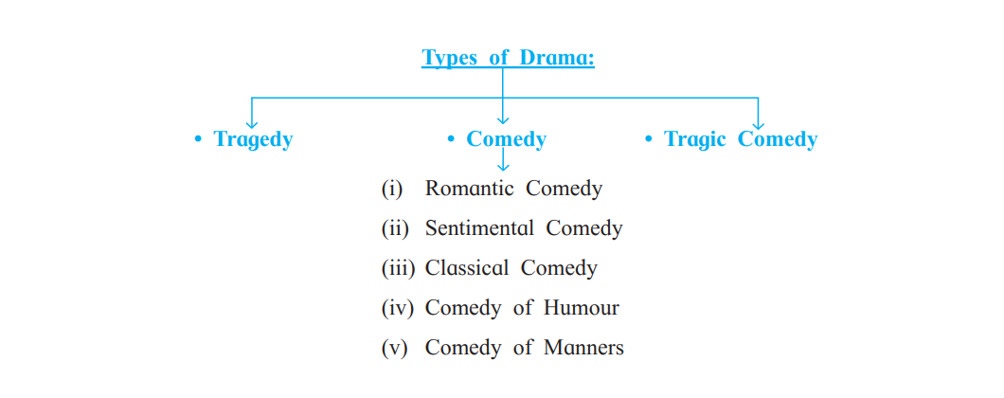 **A**

**Short History of Drama**

**I) Introduction to English Drama**

The beginnings of drama in England happened when Romans were in England, they established vast amphitheatres for the production of plays. Amphitheatres were used for the sitting arrangement for the audience.. Between the 13th and 14th century Miracle Plays started. These plays focused on the representation of Bible stories in churches.After that Morality plays became popular in 15th and 16th century Europe. They used allegorical stories to teach a moral message, promoting Christian teachings.

**Elizabethan Drama** – Also known as English Renaissance theatre, refers to the theatre of [England](https://en.wikipedia.org/wiki/England) between 1558 and 1642. The Elizabethan theatre was the dominant form of theatre in England during the reign of Queen Elizabeth I. It began in the late 1570s with the **first professional theatres**, and lasted until the Puritanical movement of the 1630s. The Elizabethan theatre was a highly popular and influential form of entertainment. The Elizabethan theatre was born out of the need for entertainment during a time of great political and social turmoil. England was recovering from a devastating civil war, and the country was plagued by religious and political unrest. The theatre provided a much-needed escape from the reality of everyday life. William Shakespeare and Christopher Marlowe were widely regarded as one of the greatest playwrighters of this period. The Elizabethan theatre closed in 1642, when the Puritans banned all public performances.

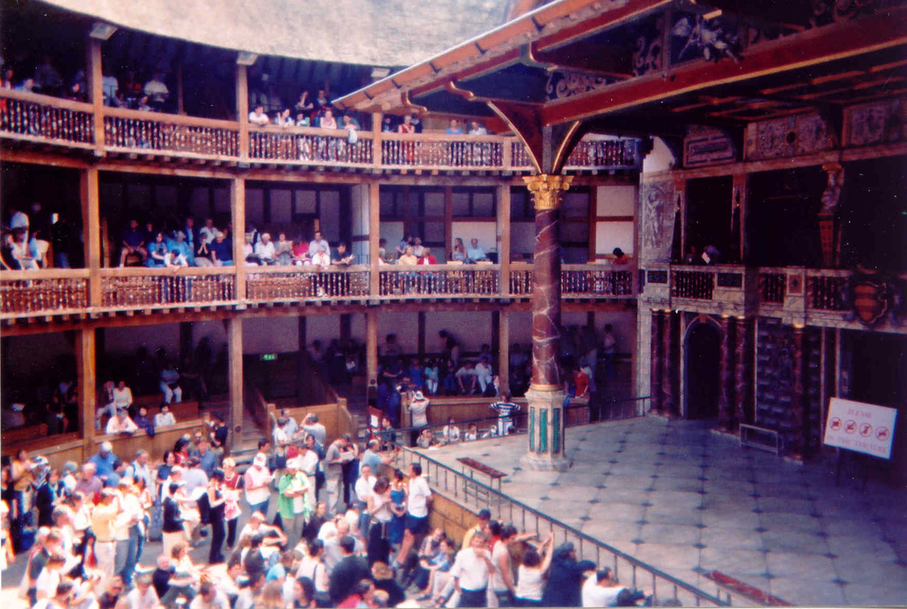

**Puritan Age (1642-1660)** The Puritan age is named after the rise of the Puritan movement in England which happened in the 17th century. Puritans, were a group of English speaking Protestants who were dissatisfied with the religious reformation movement carried out during the reign of queen Elizabeth. They wanted a complete purification of Church of England and removal of various rituals of the church, which were associated with Rome. They stood for what they believed was pure Christianity (hence, the name Puritan). This time period saw very little theatrical activity in England as the Puritan considered theatre as immoral.

**Restoration drama**

It was an important time for drama, as the theatres were reopened in 1660 after being closed under the Puritans for 18 years. This also marked the start of women performing on the English stage. With the Restoration, i.e. the re-establishment of the monarchy in England in 1660, theatres re-opened, popular plays were performed again, and there was also a demand for new dramatists and their works.

In addition, Restoration drama was marked by a focus on wit and satire. This focus on wit and satire reflected the changing attitudes towards authority and tradition in the period.

Restoration drama also witnessed the emergence of the comedy of manners as a defining characteristic. This form of play ridiculed the social conventions and manners of the upper classes and featured witty dialogue and intricate plots.

**Modern Drama**

Plays written in the 19th and 20th centuries comes in the category of modern drama. These dramas depicts the development that occurred on the political, social, economic, religious and psychological level. Faith was replaced by reason. Modern dramatists made efforts to deal with real problems of life in realistic manner in their plays. Comedy of Manners became popular in modern drama where the society standras were made fun.Realism is the most significant and outstanding quality of Modern English Drama. The dramatists of the earlier years of the 20th century were interested in naturalism and it was their endeavor (try) to deal with real problems of life in a realistic technique to their plays.

The modern drama has developed the Problem Play and there are many Modern Dramatists who have written a number of problem plays in our times.

The stage is used by dramatists to give expression to certain ideas which they want to spread in society.Modern English drama refers to plays written in the 19th and 20th century. It deals with real situations: real characters, real incidents, the use of everyday language. It also deals with common man, an ordinary man who suffers the difficulties of life. This type of drama is called anti-hero drama.

It was Henrik Ibsen, the Norwegian dramatist who popularised realism in Modern Drama. He is famously known as the Father of Modern Drama.He dealt with the problems of real life in a realistic manner of his play.The modern drama has developed the Problem Play and there are many Modern Dramatists who have written a number of problem plays in our times. Henrik Ibsen’s play A Doll’s House is a good example of a problem play. In it, the dramatist focuses on the fake relation of modern marriage. The woman’s place starts to emerge gradually after a long years of exploitation and deprivation.

**Indian theatre**

It began as a narrative art form that combined music, dance, and acting. Earlier seeds of modern drama can be found in the Sanskrit Drama. Brahma created the Natya Veda for the pastime of Gods, according to Bharat Muni's Natya Shastra, by combining elements from the four Vedas. It also gives mythological account of the origin of theatre. It is a significant contribution to the world of Indian theatre. Natya shastra is the first formal treatise on dramaturgy and was written between 200 BC and 200 AD. It describes ten types of plays, ranging from one-act to ten acts, and covers all aspects of classical Sanskrit literature.

**One Act Plays**

A one act play is a short complete story that has to be performed on the stage in stipulated time. The action is confined to a single place and the number of characters is limited.

**A one-act play must have the following characteristics and components:**

1. One-act play is a play that has only one act, but may consist of one or more scenes.

2. One-act plays are usually written in a concise manner.

3. It deals with a single dominant situation, and aims at producing a single effect.

4. It deals with only one theme developed through one situation to one climax in order to produce the maximum of effect.

5. It treats the problems of everyday life as marriage, punishment for crimes, social and political conditions, divorce, etc.

6. The one-act play, like the longer drama, should have a beginning, a middle and an end. It may be divided into four stages- The Exposition, The Conflict, The Climax and The Denouement.

(a) The exposition is usually brief, serves as an introduction to the play.

(b) It is through the conflict that the action of the drama develops. It is the very backbone of the one-act play.

(c) Climax is the turning point of the drama. It is an important part of the one-act play and constitutes its moment of supreme interest.

(d) The Denouement is very brief and often overlaps with climax. the end of a play, book, etc., where everything is explained or settled; the end result of a situation

7. Everything superfluous is to be strictly avoided as the play is short and the action takes place within a short period of time.

8. There are three dramatic unities which are observed in the one-act play. The unities are **the unity of time, unity of place and the unity of action.**

9. The characters in a one-act play are limited in number. The characters should be limited to two to seven, with one clear main character.

10. The characters in the modern one-act play are ordinary men and women. It depicts characters that seems to be real and related to everyday life.

11.The language of the dialogue should be simple, brief and easy to understand.

12. The one-act play requires no elaborate setting and costumes.